Programming Assignment 2
Varun Gunda
A20453991

1. Tracing the read system call:

The user level program “read_test.c” starts with opening a non-existing file which returns undefined file descriptor. The program is as shown below:

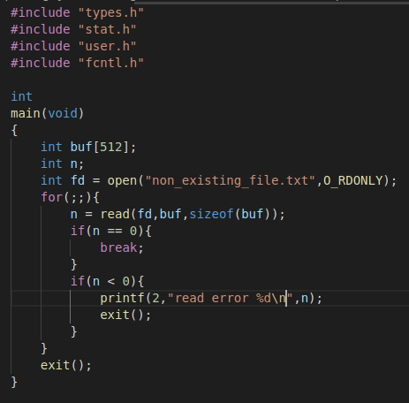

The above program calls open system call on a non existing file and this returns non existing file descriptor. Now this file descriptor is passed to the read() system call.

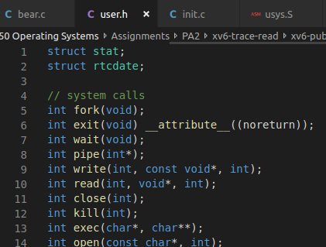
The read() system call is declared in the header file
“user.h”:

The read command takes the execution to usys.S program which is connected to “read_test” executable at the time of linking. Line 15 is the line that will be executed in this assembly code (based on the system call name and here it is “read”). SYSCALL macro is defined in line 4 in this file which moves the value of SYS_read to %eax. The value of SYS_read is defined in “syscall.h”
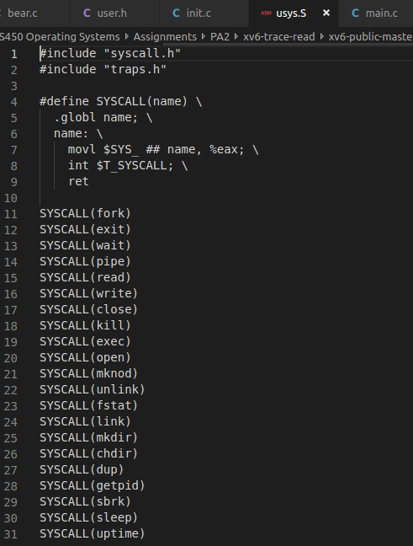
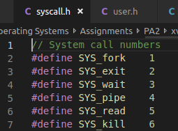

The next step in usys.S raises an interrupt using “int” command and the type of interrupt i.e., “system call” is given by $T_SYSCALL which is defined in “traps.h” (Check the following snippet).

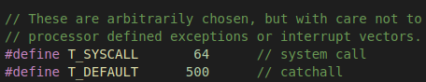

Once the interrupt is raised, it means usys.S is asking the kernel to run the “read” system call. The execution then moves to trapasm.S where the hardware moves all the registers to per process kernel stack (build trap frame section in the code below) to retrieve them later on after the “return from trap” is completed.
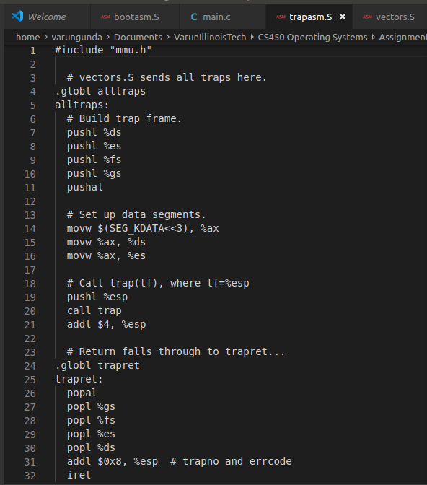

After moving all the registers to per process kernel stack safely, trap instruction is executed at line 20 of trapasm.S. Now the OS runs in kernel mode and the execution moves to trap.c’s trap() function.

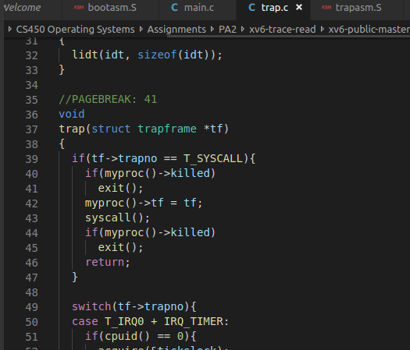

The trap function checks the type of interrupt and here since it is system call it enters the “if” branch in line 39 in trap.c. Now, the syscall() function is called at line 43 which takes the execution to line 141 of syscall.c.

Actually, the trap vectors are initialized at the boot time of xv6 and will be remembered till the system is shut down. This function tvinit() is called in main.c’s main() function. This tvinit is defined in trap.c. These trap vectors maps the trap instruction to correct system call.

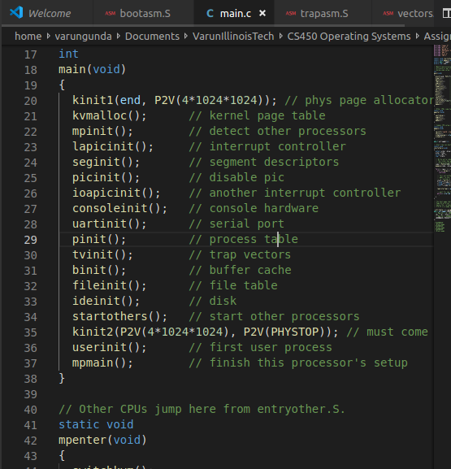
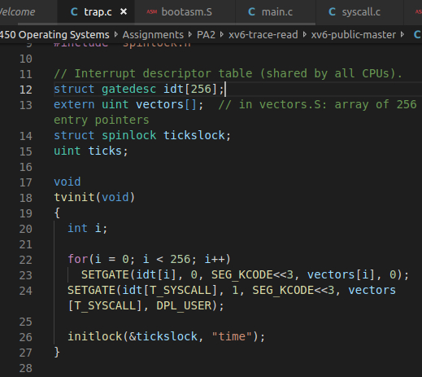

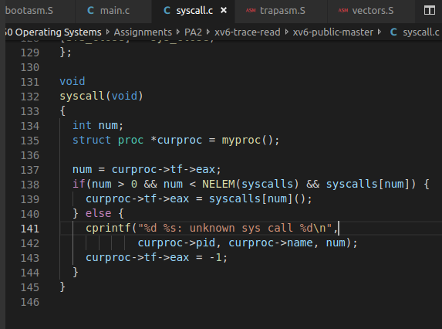
Moving on to the syscall.c’s syscall() function (shown below), the system call number will be loaded in line 137 which is stored in current process’s trap frame. Depending on the number that is stored in eax register previously in usys.S the appropriate system call will be called. Since we are dealing with read system call, the sys_read() function of sysfile.c is called. OS now executes sysfile.c’s sys_read function.

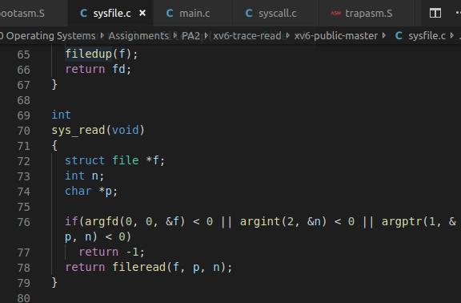
Here in sys_read() function, there are variables declared at the beginning to store:
a. The pointer to struct file structure variable which is passed by user program
b. Integer n which represents the size of the element passed by user program
c. Char pointer which represents the memory passed by the user program.

The execution is now moved to argfd(), the first function in the if condition of line 76.

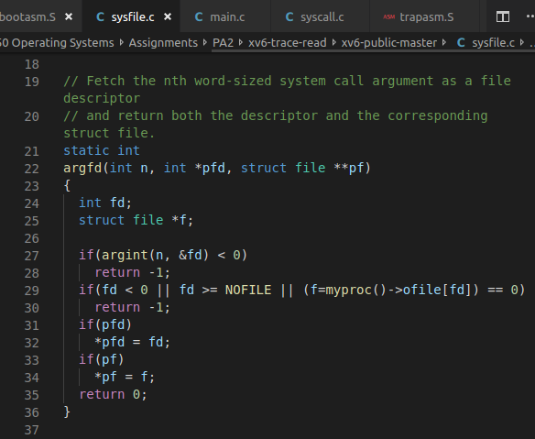
The argfd() is defined in the same file sysfile.c. This function inturn calls the function argint() in line 27.

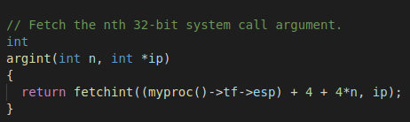
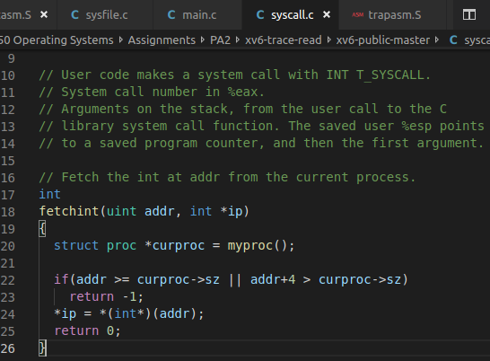
The argint() function is defined in syscall.c. This function in turn calls fetchint() function in the same file.
The fetchint() function takes in the arguments addr which stands for program counter’s address and ip stands for the pointer to the integer that is set to “fd”.

Coming back from the argint() function, the next if condition in line 29 is executed. Since fd is “-1” here “fd<0” evaluates to true and “-1” will be returned from line 30. From here the value is returned to sys_read() function in syscall.c.

Since “argfd(0,0,&f) < 0” condition is satisfied in line 76, -1 will be returned to the caller function syscall in syscall.c.

The returned value -1 is stored in eax of current processes trap frame and the function syscall returns to the function trap() in trap.c which in turn returns to trapasm.S

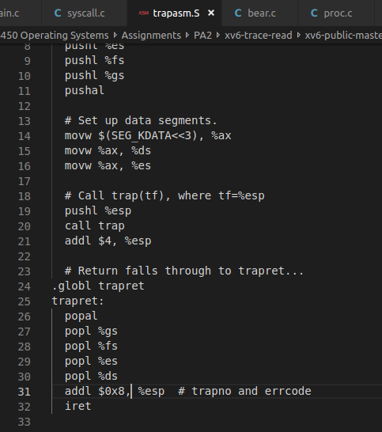
Now the hardware restores the registers from kernel stack as shown in the lines after call to trap in trapasm.S under trapret section. popal here restores general registers and the next instructions from line 27 restores registers gs,fs,es,ds. Also, the trap code is popped in line 31.

The running mode is now switched to “user” level and the execution of the user level program continues from the point where system call is executed in user program.

Since, fd is bad read gives a value -1 and hence we receive the error output.

